Fauquier Community Action Committee

HEAD START
Annual Report
2021-2022

Mission Statement

The Mission of the F.C.A.C. Head Start Program is:

“To provide a quality and comprehensive,
Head Start program for the
children and families that we serve.”

Incorporating other services directed toward promoting total family self-sufficiency, encouraging parents to take an active role in the education of their children and transitioning the children into the school system by mobilizing all available resources through community awareness, involvement, and support.

BOARD OF DIRECTORS AND POLICY COUNCIL Program Year 21-22
Janice M. McNulty-President of Board of Directors Roger Sites-Vice President
Ellie Kay-Secretary/ECH Specialist John C. Harrison-Treasurer
Ann Callaway-Member-Attorney at Law Darcy Owens-Member
Doris Pettis-Member Matt Yonkey-Member
Nikki Synder-Rep. From Policy Council to Board

Policy Council Members
Nikki Snyder-President of Policy Council Evelin Blanco-Vice President
Shanise Terry-Treasurer Laura Billings-Secretary
Eva Pierce-Member Vanity Jackson-Member
Judy Koehler-Community Candance Simpson-Community-Nurse Practioner
Doris Pettis-Chaplin-Rep. From Board to Policy Council

FCAC Head Start Demographics

Administrative Staff:
Head Start Executive Director-Patricia A. Washington
Program Assistant/Receptionist- Terry Collins
Fiscal Officer- Bethany Walton
Education Manager- Linda Watson
Health Services Manager-Sherry Brodnax
Mental Health / Coaching & Mentoring Case Manager- Ryan Washington
Disability / Coaching & Mentoring Case Manager- Kailyn Logan
Parent / Family Engagement Supervisor-Mildred Washington
Family Service Workers- Victoria Arellano
Stephanie Miller
Yoseli Flores

Head Start Education/Transportation Staff:
Teachers: 8
Assistants: 10
Bus Drivers: 6
Bus Monitors: 6

Head Start Classrooms:
FCAC Head Start has 8 classrooms in 3 centers throughout Fauquier County

Head Start 2021-2022 Budget

 | Awarded | Budget | Actual
Personnel | 1,000,753.00 | 986,404.00 | 1,000,753.00
Fringe Benefits | 191,165.00 | 189,617.00 | 191,165.00
Travel
Supplies (Office/Classroom) | 31,500.00 | 31,500.00 | 31,500.00
Contractual/Consultants | 92,410.00 | 92,410.00 | 92,410.00
COVID  ARA | 41,835.00  122,154.00  166,314.00 |  | 41,835.00  122,154.00  166,314.00
Other | 78,112.00 | 77,867.00 | 78,112.00
Non-Federal Share | 348,598.00 |  | 348,598.00
T&TA (Training and Technical Assistance) | 17,766.00 | 17,766.00 | 17,766.00
TOTAL HEAD START APPROVED BUDGET | 1,394,390.00 | 1,394,390 | 1,394,390.00
Fiscal year ending June 30, 2022, audit showed no findings

Education
Achievements:
Child Development Associate Credential (CDA)
3 Teacher Assistants received their CDA on 5/18/2022
5 Teachers have waivers and are enrolled in courses to receive Associates in ECH
Head Start Reading Program
Every family was encouraged to read at least one book to their child every week of the month for the months of October, November, December, January, February, March and April.
The families read a total of 852 books from October 2021-April 2022
Parent Activity Calendar
Parent Activity Calendars were sent home monthly to all the families. The activity calendar had a variety of activities for parents to complete with their child to promote school readiness in the home. Every month the calendar featured a different aspect of school readiness. From October 2021-April 2022 a total of 126 calendars were returned.
Teddy Bear/Transition Picnic
FCAC Head Start did not hold its annual Teddy Bear Picnic. Parents were given a Transition to Kindergarten packet, children books, information about where food sites were being held, and application for free backpacks and school supplies. Also, information about the Summer Enrichment Program.

School Readiness
School Readiness is a high priority for Head Start programs. Head Start’s approach to school readiness means that children are ready for school and families support their children’s learning. The Head Start program partners with parents in establishing kindergarten readiness goals that support children’s progress across five early childhood learning domains. These domains include (1) language & literacy (2) cognition, (3) approaches towards learning, (4) perceptual, motor, and physical development and (5) social and emotional development. These domains represent a critical area of learning and development for young children. All goals are aligned with the Head Start Framework, State Early Learning Standards, and Virginia Foundation Blocks for Early Learning. Parents are encouraged to be involved in their child’s school readiness whether through reading to their children, activities in the home, or attending parent center meetings/trainings with the focus on school readiness.
School Readiness Goals 2022
Table of Contents
- Four Year Old Overall Scores
- Three Year Old Overall Scores
- ESL Overall Scores
- Individual School Readiness Goals by Classroom
  - Approaches to Learning
  - Social and Emotional Development
  - Language and Literacy
  - Mathematics
  - Perceptual, Motor, and Physical Development

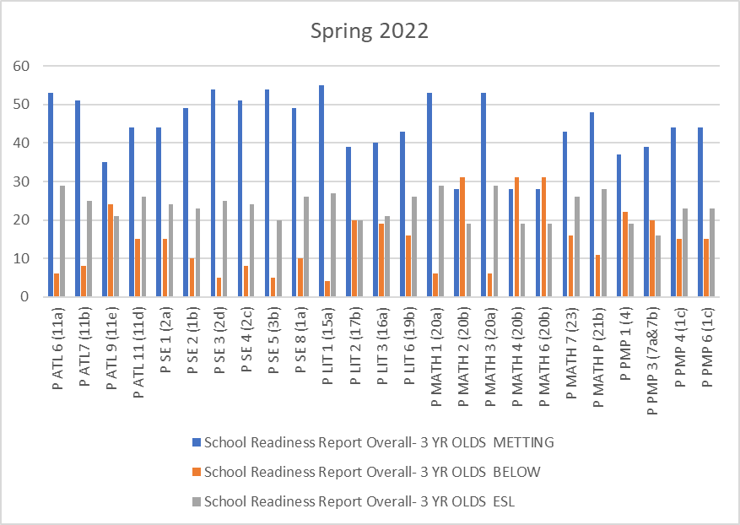
This graph shows the overall score for the four-year old’s in the Spring of 2022. The blue indicates the children are meeting the Goal. The orange shows the children that are not meeting the goal according to FCAC Head Start goals for the program. Children that are in are in the age appropriate range for children nation – wide through Teaching Strategies. The children in the grey are Dual Language Learners. In the Domain Approaches to Learning (P ATL 6, 7, 9,11) we have 76% or higher have met this goal. In the Domain Social and Emotional Development (P SE 1, 2,3,4,5,8) we have 81% or higher of four-year old’s meeting this Domain. In the Domain Language and Literacy (P LIT 1,2,3,6) we have 71% or higher of four-year old’s meeting this Domain. In the Domain Mathematics (P MATH 1,2,3,4,6,7,P) we have 86% or higher of four year old’s meeting this Domain. In the Domain Perceptual, Motor, and Physical Development (P PMP 1,3,4,6) we have 64% or higher of four-year old’s meeting this Domain.

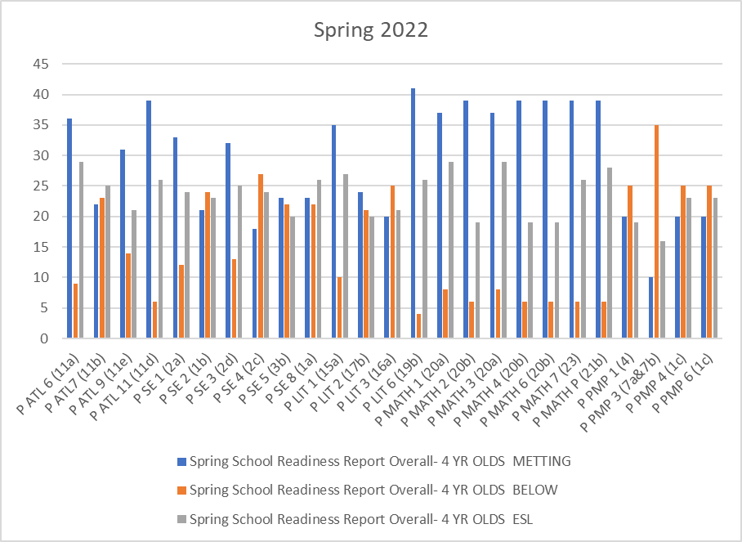

This graph shows the overall score for the three-year old’s in the Spring of 2022. The blue indicates the children that are meeting the Goal. The orange shows the children that are not meeting the goal according to FCAC Head Starts spring goals for the program. Children that are in the orange are in the age appropriate range for children nation-wide through Teaching Strategies. The children in the grey are the dual language learners. In the Domain Approaches to Learning (P ATL 6,7,9,11) we have 85% or higher have met this goal. In the Domain Social and Emotional Development (P SE 1,2,3,4,5,8) we have 75% or higher of three-year old’s meeting this Domain. In the Domain Language and Literacy (P Lit 1,2,3,6) we have a range of 67% or higher of three-year old’s meeting this Domain. In the Domain Mathematics (P MATH 1,2,3,4,6,7,P) we have 90% or higher of three year old’s. In the Domain Perceptual, and Physical Development (P PMP 1,3,4,6,) we have 52% or higher of three-year old’s meeting this Domain.

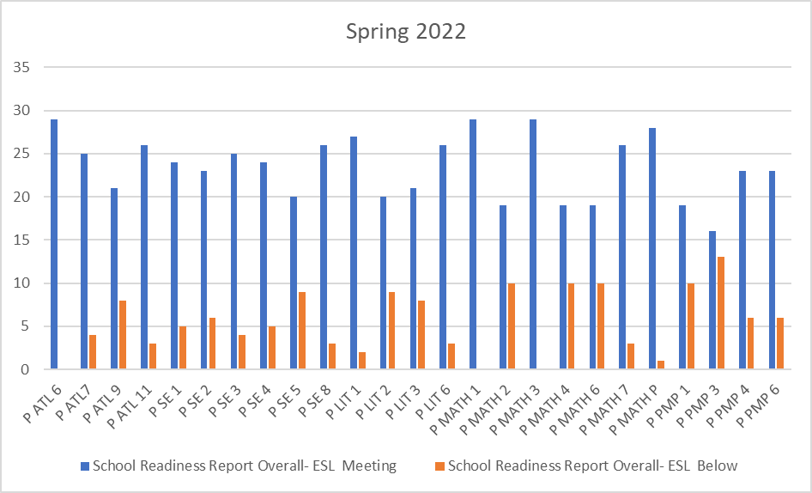

This graph shows the overall score for the ESL students in the Spring 2022. The blue indicates the children that are meeting the goal. The orange shows the children that are not meeting the goal according to FCAC Head Start goals for the program. Children that are in the orange are in the age appropriate color range for children nation-wide through Teaching Strategies. In the Domain Approaches to Learning (P ATL 6,7,9,11) we have 85% or higher have met this goal. In the Domain Social and Emotional Development (P SE 1, 2,3,4,5,8) we have 93% or higher have met this goal. In the Domain of Language and Literacy (P LIT 1,2,3,6) we have 76% or higher have met this goal. In the Domain Mathematics (P Math 1,2,3,4,6,7,P) we have 67% or higher have met this goal. In the Domain Perceptual, Motor, and Physical Development (P PMP 1,3,4,6) we have 87% or higher have met this goal. There are 23 ESL children in the Program.

Curriculum and Screening Tools

FCAC Head Start uses the Creative Curriculum. The Creative Curriculum is a research-based curriculum that uses exploration and discovery as a way of learning, The Creative Curriculum enables children to develop confidence, creativity, and lifelong critical thinking skills. It is based on 38 objectives for development and learning, which are fully aligned with the Head Start Child Development and Early Learning Framework and the Kindergarten Readiness Preschool Program. (Virginia State Standards).
Developmental and Social Emotional Screenings:

Brigance Screening Tool – Developmental screening administered in the fall and spring to all 3- and 4-year-old children. Brigance examines the following: color recognition, picture vocabulary, number recognition, body part recognition, visual discrimination, fine motor skills and gross motor skills. Brigance helps to identify strengths and weaknesses and helps the teacher to individualize the activities for each child.

89% of Head Start children met the benchmark score for their chronological age.

Pals Pre-K- Pals Pre-K are administered to 4-year old's in the fall, winter, and spring in order to guide individualized instruction during the year. The second administration is given in the winter, and the third administration is given in the spring to track the progress made. The assessment reflects skills that are predictive of future reading success and measures name writing ability, upper-case and lower-case alphabet recognition, letter sound and beginning sound production, print and word awareness, rhyme awareness, and nursery rhyme awareness.

4 year old Pals Pre-K
 | Fall | Spring
Name Writing | 35% | 84%
Upper Case Alphabet Recognition | 45% | 79%
Lower Case Alphabet Recognition | 37% | 77%
Letter Sounds | 26% | 80%
Beginning Sound Awareness | 47% | 87%
Print Word Awareness | 36% | 85%
Rhyme Awareness | 26% | 85%
Nursery Rhyme Awareness | 37% | 90%

Parent, Family and Community Engagement

Community Partnerships- FCAC Head Start currently has partnerships with many community agencies to support the needs and goals of Head Start families and children. (For a complete list please see pages 28-31.)

Follow Up
- Goal Follow-up: Family Service Workers followed up with each family on a monthly basis after the family goal had been set.

- Health Follow up: Family Service workers followed up on the children’s health needs including children needing Pediatric dental care, physical requirements, low hemoglobin, failed vision screens, etc.

- Classroom Concerns/Bus Concerns: Family Service workers work closely with each teacher and bus driver. When there was a concern the family service worker worked with the teacher and/or bus driver to help overcome any concern.

- Attendance: Family Service workers follow-up on children who have been absent 3 consecutive days.

- Food: Work closely with Fauquier School Nutritionist to provide weekend food packs to children and families.

- FISH:Work closely with them to provide weekly food packs to children and families.

Family Service Family Outcomes Goal Setting
Spring 2021
Family Outcomes:
- Family Well-Being
- Positive Parent-Child Relationships
- Families as Lifelong Educators
- Families as Learners
- Family Engagement in Transitions
- Family Connections to Peers and Community
- Families as Advocates and Leaders

Levels
- Low
  - Level 1 - Goal Set
  - Level 2 – First Step
- Medium
  - Level 3 – Making a plan towards goal completion
  - Level 4 – Midway through goal progress, and continually working to completion
  - Level 5 – Almost there
- High
  - Level 6 – Final process in goal completion
  - Level 7 – Goal Accomplished
  - Level 8 – Celebrate Success

Family Well Being
Families are safe, healthy, have opportunities for educational advancement and economic mobility, and have access to physical and mental health services, housing, and food assistance, and other family support services.

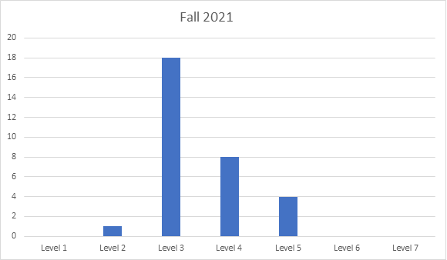
- This section makes up 30 % of the goal setting areas
- 31 children have goals in this area

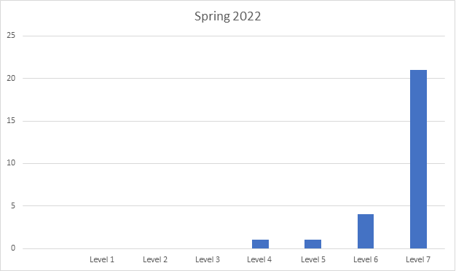

- All children have progressed
- 27 children in this area
- 30% of all goals in this area
Positive Parent-Child Relationship
Beginning with transitions to parenthood, parents and families develop warm relationships that nurture their child’s health, development, and learning.

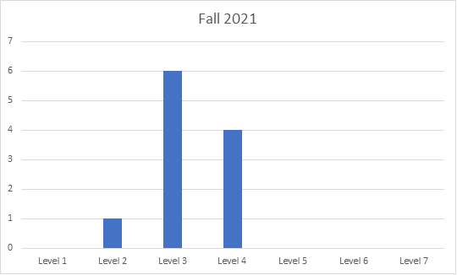
- This section makes up 11 % of the goal setting areas
- 11 children have goals in this area
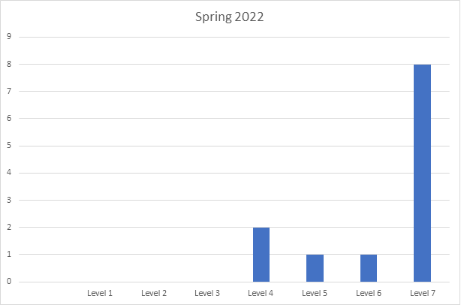

- All children progressed
- Level 4 – 2
- 12 children are in this area
- 13% of children are in this area

Families as Lifelong Educators
Parents and families observe, guide, promote, and participate in the everyday learning to their children at home, at school, and in their communities.

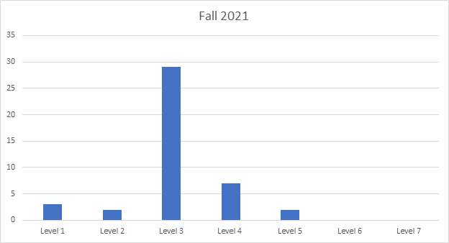
- This section makes up 43 % of the goal setting areas
- 42 children have goals in this area

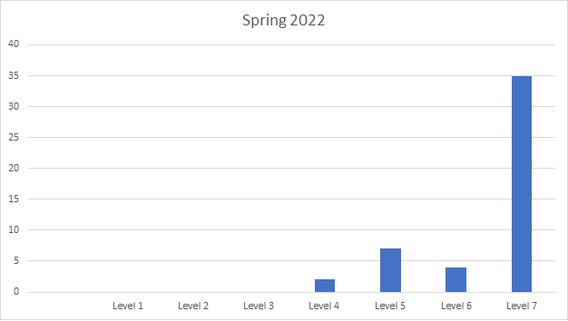

- Level 4 – 2
- 53% of goal setting in this area

Families as Learners
Parents and families learn about their child’s personality, development, and learning style. They also advance their own learning interest through education, training, and other experiences that support their parenting, careers, and life goals.

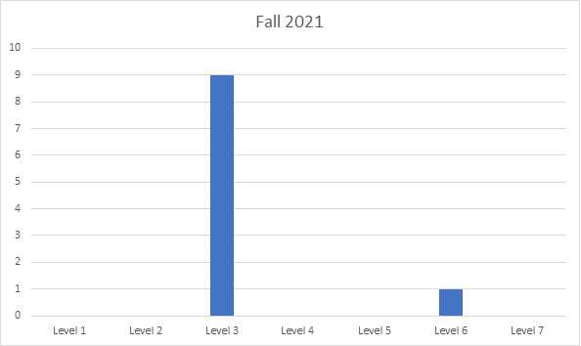
- This section makes up 9 % of the goal setting areas
- 10 children have goals in this area

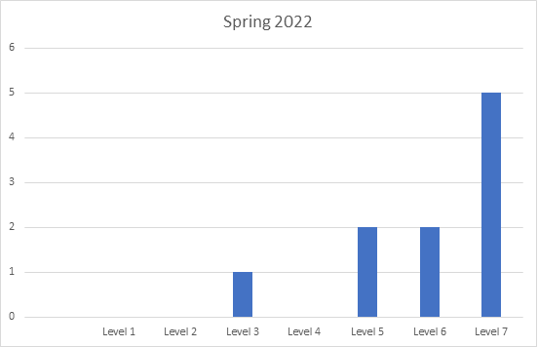

- Level 3 – 1
- 10 children in the area
- 11% of total goals are in this area

Family Engagement in Transitions
Parents and Families encourage and advocate for their child’s learning and development as they transition to new learning environments within and between, Early Head Start, Head Start, Early childhood services, early elementary grades, and beyond.

- None at this time

PARENT AND COMMUNITY ENGAGEMENT
Parent Involvement

Total Volunteer Hours for 2021-22: 505.0 hrs.
Volunteer hours for the 2021-2022 school year were lower than previous years due to the COVID-19 pandemic and not having volunteers in the building.

Parents were involved virtually through at home projects. 91 parents participated in the home activities.

Services and Referrals
Food Bank/Power Pack | 58
Home Visits completed (via phone/in office) | 116
Transportation | 7
Housing/Clothing | 2
Mental Health Referrals | 5
GED | 3

Parent Involvement
FCAC Head Start offers many opportunities throughout the year for families to participate. All parents are invited to participate in all activities including…

- Virtual Parent Center Meetings: Once a Month (take home projects)
- Policy Council Meetings
- Trainings/workshops
- Field Trips
  - Cox Farm- Pumpkin Patch in October
- Health/Education/Family Engagement Advisory Board
  - Meeting with community organizations to discuss the Health/Education/Family needs of Head Start families and children.

Enrollment Statistics

The family service staff records all enrollment/attendance information on all children and families.

Year to date number of children served: 116
Drops: 12

Eligibility by Primary Type of Eligibility

72- Income Eligible
14-Over income children
11-Foster
13-Homeless
6-Public Assistance
(Including children that dropped)

Average Monthly Attendance for Program Year 2021-2022

It is required for all Head Start programs to have at a minimum 85% attendance each month.

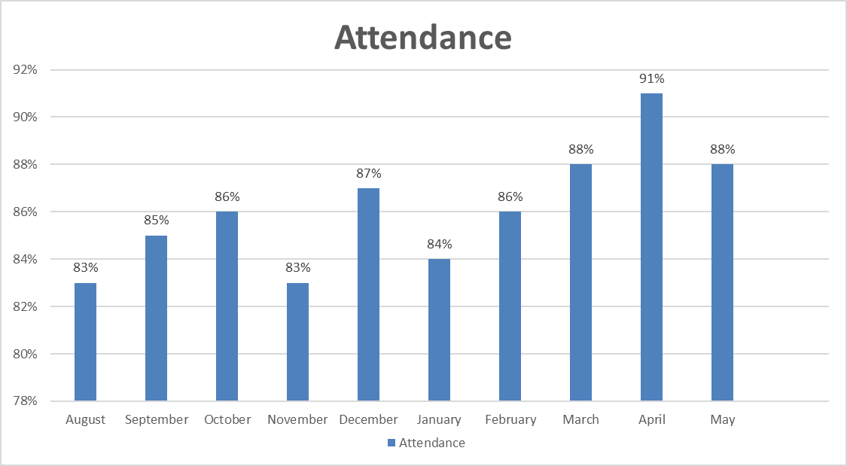

Year End Average Attendance for 2019-2020: 93%
2021-2022: 86%

Health Services

The focus of Head Start health services is to prevent health problems whenever possible by carefully addressing the needs of enrolled children. Successful partnerships are the key to the success of this approach. When conditions or illnesses are found, they are addressed quickly with the help of competent health care partners in an effort to improve the health of the child and to prevent future problems.

FCAC, Inc. Head Start Health Services provides:

- Health Screenings to all enrolled children including Hearing, Vision, Speech and Language.
- Assisting families in finding a medical home/dental home.
- Tracking all health services.
- Offering training/information to families about: Nutrition, Family Wellness, Dental Awareness, Communicable diseases, child health and safety etc.
Health Services | At the End of the Program Year | Cancellations Due To COVID-19/ or comments
Children with Health Insurance | 112
Children with No Health Insurance - 3 born out of country | 4 | 3 Born out of country  1 will put child on their insurance.
Children with a Medical Home | 114 | 2 children dropped
Children with Up-to-Date Immunizations, and up to date for child’s age. | 112 | 2 children are exempt  2 children with no immunizations dropped from the program.
Children who received preventive dental care | 111 | 2 children dropped/3 did not make appointments.
*Children who required Dental Treatment | 25 | 17 Children completed their dental treatment.  2 Children dropped, and 6 are still in care.
*Children that dropped before completing dental treatment | 2
*Currently In Dental Treatment | 6 | The 6 children are still receiving care and have scheduled appointments foe the summer.
*Children that completed their dental treatment | 17
*Refused Dental Treatment | 0
Children that received Speech and Language Screening | 112 | 3 children dropped; 1 child started late.
Children that received Hearing and Vision Screening | 112 | 3 children dropped; 1 child started late.
*Children referred to Pediatric Ophthalmologist | 11 | 9 received glasses, and 2 have appointments scheduled
*Children referred to a Pediatric Ophthalmologist who received glasses | 9 | 2 have appointments during the summer.

Health Tracking

Health tracking is crucial to ensuring that children receive services in a timely manner. The Health Services Manager works with the community physicians to ensure that children are current on their physical exams and up to date with their immunizations according to the ESPDT guidelines. Children who need medical follow-up are reminded to take their children for rechecks and other necessary follow-up. The Health Services Manager works with the physician to see if parents have followed-up with the concerned conditions. The Health Services Manager and Family Service Workers work with the families regarding chronic medical conditions and the physician’s office to acquire information regarding child status.
The Health Services Manager works closely with the Fauquier Free Dental Clinic to ensure that children receive an initial dental exam. Children who need further dental care are referred to a pediatric dentist within the county or surrounding areas.
The speech and language screening are done by a private speech pathologist. Referrals from these screenings are shared with the parents and with their permission follow-up is done with a community partner to ensure that the child receives the required services.
Hearing and Vision Screenings are done by the Fauquier Sunrise Lions Club using the Spot Vision machine to do vision screens.

Chronic Medical Conditions
During Program year 2021-2022 there were children being followed up by the health manager for chronic health conditions. The Health Services manager worked closely with each family to ensure their needs were being met. Children with Asthma are receiving medical care. Two children were anemic: they are under a doctor's care. One child was diagnosed with obesity concerns. Children with chronic medical conditions are being taken care of by their physician.
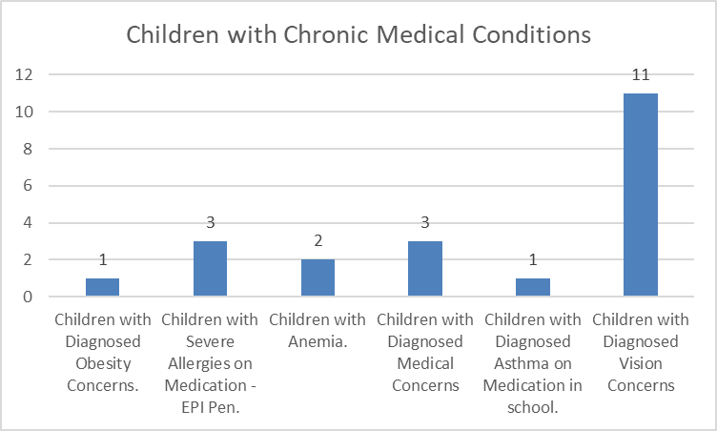

Disabilities
The Family Services/Disabilities Case Manager, teachers, and parents work closely together throughout the school year to ensure that every student maximizes his or her ability to learn. Each year our students are screened within 45 days of entering the classroom for speech and language, vision, and hearing. The teachers and assistants also administer developmental and literacy evaluations at the beginning and end of the school year to assess each child’s abilities, and we continue to monitor each child’s progress throughout the year. Our Head Start program works closely with Fauquier County Public Schools Special Education Department to help meet the educational needs of our students.
Disability Services
- Children that had an IEP and were determined to be eligible for services prior to enrollment year- 0
- Children that obtained an IEP and became eligible to receive services during enrollment year- 16
- Children referred for evaluations to receive services- 19
Of these:
  - Children who went to Child Study meeting-19
  - Children who went to Eligibility meeting- 16
  - Children who went to IEP meeting- 16
- Children diagnosed with Developmental Delays- 4
- Children diagnosed with Speech/Language Impairment- 12
- Children diagnosed with Autism-1
- Children diagnosed with Hearing Impairment-0
- Children with Individual Service Plans- 1
  - The child met ALL goals on Individual Service Plan

Coaching/Mentoring
- Teachers were coached on a range of School Readiness Goals this year
- The teachers focused on Social Emotional Development and Mathematics
- Supplies were bought to enhance the learning experience for children and staff in the areas of math and science.

Mental Health
Devereux Early Childhood Assessment for Preschoolers Second Edition (DECA-P2)- Tool completed by the teacher in the fall and spring that looks at Initiative, Self- Regulation, Attachment/Relationships, and Behavioral Concerns.
Devereux Early Childhood Assessment for Preschoolers (DECA-P2)
Classroom: Head Start Program Wide
Findings:
- Areas of strength:
  - None
- Typical Areas:
  - Behavioral Concerns- FCAC ranks in the 21st percentile.
  - Initiative: FCAC is in the 79th percentile.
  - Attachment/ Relationships- FCAC is in the 82nd percentile.
  - Total Protective Factors: FCAC is in the 90th percentile.
  - Self-Regulation - FCAC Ranks within the 88th percentile
- Areas of Need:
  - None
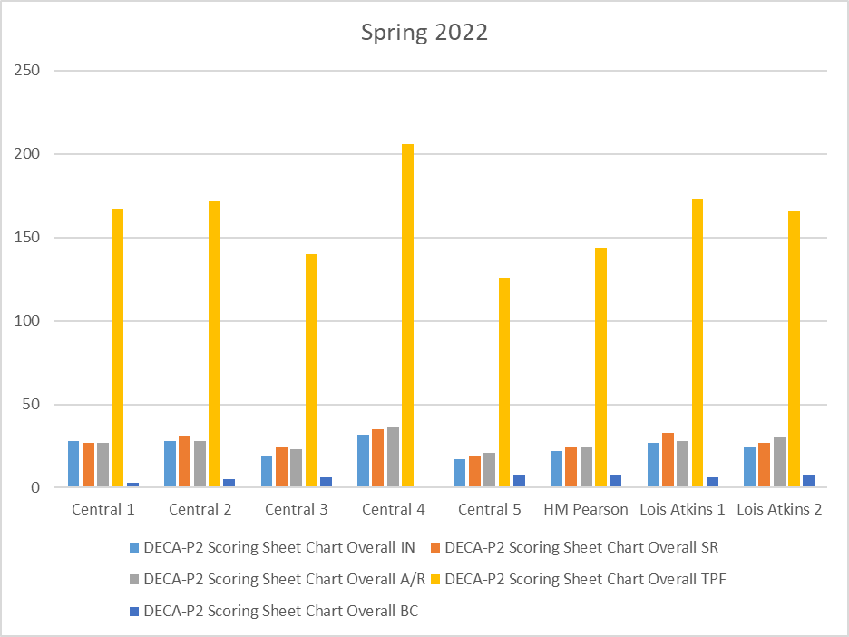
From the fall to the spring the program has made strides in all areas, with no areas of need. Behavioral concerns went from the 36th percentile to the 21st in the spring. Initiative went from 47th percentile to the 79th percentile. Attachment/Relationships went from 52nd percentile to the 82nd percentile. Self-Regulation went from the 65th percentile to the 88th percentile. Total protective factors went from the 72nd percentile to the 90th percentile.
· 4 children were observed closely this school year to monitor behavior

FCAC, Inc. Head Start Community Partners

Community Agency Service/s provided to Head Start

Fauquier County Public Schools | Provide space for 8 Head Start classrooms  Provide space for Head Start to use for program in-kind
Fauquier County Public Schools:  Special Education Department | Complete testing on children who are referred  Provide special education services to children with disabilities  Resource for teaching staff
Fauquier County Public Schools  School Nutrition Services | Has an agreement with Head Start to provide breakfast and lunch to the children
Highland School | Invite Head Start children to theatrical performances/read to children  Donate books, hats and gloves to Head Start Children
Liberty High School | Provide space to use for any Head Start event
PRACEP- Piedmont Regional Adult Continuing Education Program | Provide GED (classes/testing) and ESL classes
Literacy Volunteers of Fauquier County | Provide basic literacy skills, computer skills, ESL classes
Fauquier County Health Department | Participate on Health, Education, Family Engagement Advisory Committee  Provide Immunizations/Physicals
Northern Piedmont Community Foundation- | Nicolaas and Patricia Kortlandt Grant to purchase the new edition of the Creative Curriculum.  Grant to purchase seat belt harnesses for buses.

Capitol Group | Adopt a classroom at Christmas and provide baby doll/truck
Summit Bank | Adopt a classroom at Christmas and provide baby doll/truck
Dominion Power | Adopt a classroom at Christmas and provide baby doll/truck
Our Savior Lutheran Church | Provide Food basket to families in need
Community Touch Inc. | Assist families in need with Clothing/Furniture Vouchers
Christ Church | Provide Easter Food Basket to families in need  Adopt a classroom at Christmas and provide baby doll/truck
F.I.S.H. (For Immediate Sympathetic Help) | Attend Teddy Bear Picnic  Provide Backpacks/School Supplies to families in need
Fauquier Community Food Bank/Thrift Store | Provide food/clothing to families in need
The Wise Foundation | Donated $1,000 to the program
The Town of Warrenton | Strong Supporter for the education of our children
Loeb Foundation | Strong Supporter of Head Start children and families

Fauquier Free Clinic- Dental  Fauquier Free Clinic | Contractual Agreement to provide Dental Screenings
Lord Fairfax Community College | Work with Head Start to provide Early Childhood classes for teachers and staff
Enroll Virginia | Attended Health/Education/Parent Engagement Advisory Meeting
Fauquier County Public Library | Children visit the library on a monthly basis  Attend Parent Orientation, Transition Picnic  Work in conjunction with RIF to provide books to children  Act as a resource for teachers and staff
American Health Services Inc. | Provide CPR/First Aid, MAT training to staff and basic first aid to parents
Counseling Intervention Incorporated | Conduct monthly classroom observations  Serve as a resource to families and staff
Warrenton Sunrise Lions Club | Provide Hearing and Vision screenings to children  Volunteer during Christmas-play Santa Clause and bring gifts to children. All in-kind
Colette Reynolds, MA CCC | Provide Speech and Language Screening on all Head Start children. Provides in-kind to the program.
Virginia Cooperative Extension (SCNEP) | Provide Training and nutritional information to parents  Water bottles for all children
St. John's Catholic Church:  The Knights of Columbus  St. Vincent de Paul Society | Provide Food Baskets to families in need during Thanksgiving, Christmas and Easter  Adopt a classroom at Christmas and provide a baby doll/truck. Provide emergency utilities assistance for families in need

St. Andrew’s Church | Adopted a family for Christmas
St. John’s Baptist Church Missionary | Adopted a family for Christmas
View Tree Masonic Lodge #142 | Adopted Families at Christmas & Thanksgiving  Support Head Start with supplies
Eagle Pest Control | Adopted a classroom for Christmas
Vulcan Materials | Adopted a classroom for Christmas
S.A.F.E (Services to Abused Families) | Provide Domestic Violence, Sexual Abuse, Child Abuse Awareness training for staff and families  Resource for Families and staff regarding abuse
American Legion Post #360  Lt. Charles R. Anderson | Donated classroom supplies
St. James Episcopal Church | Volunteer readers to children in the program
Taylor Middle School | Invites Head Start children to trick-or-treat in the school
Titania Solutions Group | Huge Supporter of Head Start

We would like to thank the many parents, grandparents, community partners and staff for their support of this program!

